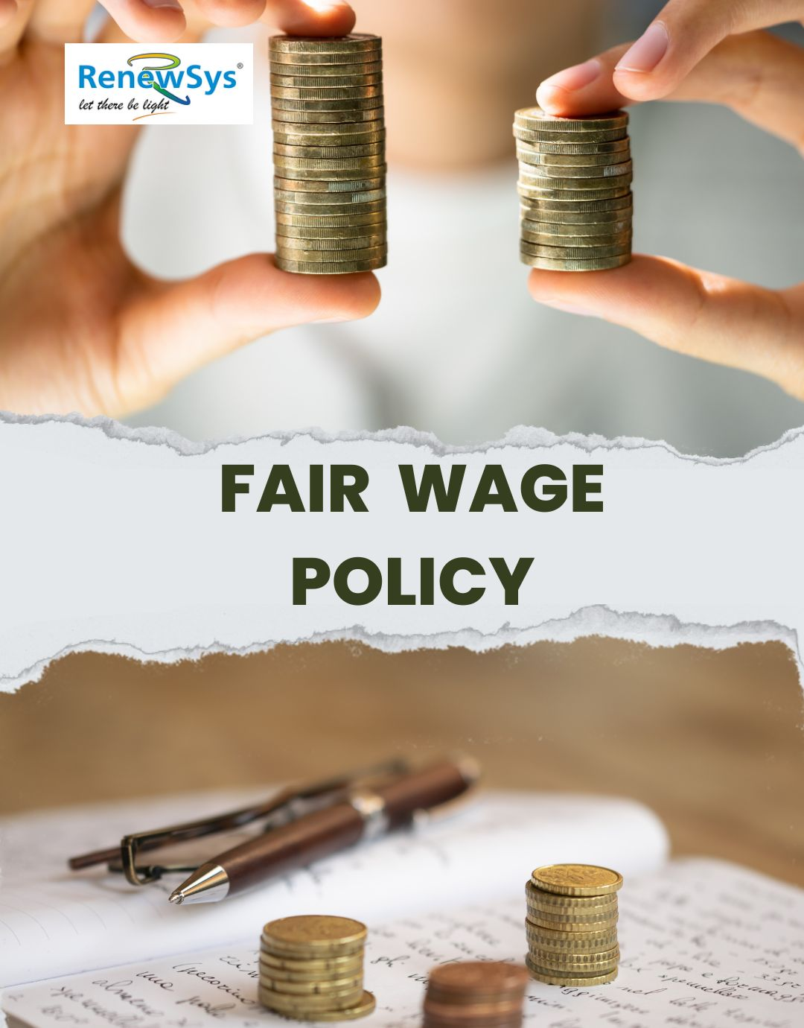

TABLE OF CONTENTS
PREFACE 2
SCOPE 2
POLICY DECLARATION 2
INITIATIVES AND TARGETS IN ALIGNMENT WITH SDGs 3
PERFORMANCE REPORTING 4
REPORTING STRUCTURE AND FREQUENCY 4
REVIEW MECHANISM 4

PREFACE

At RenewSys India Pvt. Ltd., we are committed to ensuring that our employees are compensated fairly for their contributions. Our Fair Wage Policy underscores our dedication to providing equitable, transparent, and competitive wages that align with industry standards and the specific needs of our workforce. We regularly benchmark our compensation against industry pay scales, taking into account factors such as job role, experience, and performance to ensure fairness.

We believe that fair compensation is essential for fostering employee satisfaction and loyalty. By providing wages that support our employee’ financial stability, we enable them to meet their essential needs and maintain a reasonable standard of living. This commitment not only enhances their overall well-being but also motivates them to contribute positively to our organizational goals, fostering a positive work environment where every employee feels valued and respected.

SCOPE

This Policy is applicable to following sites and all of its employees, workers, sub-contractors and other stakeholders:

Sr. No. | Site | Address
1 | RenewSys India Pvt. Ltd. | Unit No 607, 6th Floor, Trade Centre, Bandra Kurla Complex, Bandra East- 400051 Mumbai, Maharashtra India
2 | RenewSys India Pvt. Ltd. | Plot No. E-141, Additional Patalganga MIDC Industrial Area, Village - Karade Khurd, Taluka Panvel, District Raigad, Maharashtra - 410 206, India.
3 | RenewSys India Pvt. Ltd. | Plot No. 6, Survey # 114/P,  Srinagar Village, Maheshwaram Mandal, Rangareddy Dist. - 501 359,Telangana, India.

POLICY DECLARATION

At RenewSys India Pvt. Ltd., we are committed to ensuring that all employees receive fair, competitive wages aligned with their skills and contributions. With a baseline set for the year 2022-23, we will regularly assess market rates and maintain internal pay equity. Transparent communication regarding compensation matters will be prioritized, fostering an inclusive workplace for equal opportunities in career advancement.

INITIATIVES AND TARGETS IN ALIGNMENT WITH SDGs
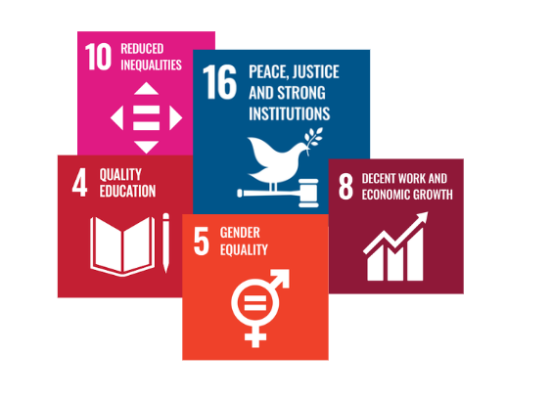

- Regularly conduct an annual review of wages to ensure equitable compensation across all departments, regardless of gender, age, or background.
- Ensure that employees receive clear and timely communication on any changes to their wages, explaining the rationale behind adjustments, to foster trust and transparency.
- Maintain an employee satisfaction score of at least 90% regarding fair wages in annual surveys by 2029-30.
- Maintain a feedback mechanism for employees to voice concerns and suggestions related to wage fairness and job satisfaction.
- Develop comprehensive career advancement programs that equip employees with the necessary skills for professional growth, thereby facilitating opportunities for fair wage increases.
- Ensure that 100% of identified wage adjustments are implemented within six months of the annual review.
- Ensure that at least 75% of employees receive a wage increase based on performance and skill development every year.
- Aim for an employee retention rate of 90% or higher annually, indicating satisfaction with compensation and overall job satisfaction.

PERFORMANCE REPORTING

The tracking and reporting on the effectiveness of the Fair Wage Policy will presented through the annual Fair Wage Performance Report. This report will provide transparency on key metrics such as wage growth, compliance with industry standards, and feedback from employees on wage fairness. These metrics will help identify areas for improvement and ensure that wages remain competitive.

RESPONSIBILITY
The Human Resources (HR) Manager will be responsible for preparing and compiling the Fair Wage Performance Report. This report will be created in coordination with:
- Finance Department for wage-related financial data and budgeting.
- Performance Management Team for data on skill-based and performance-linked wage increases.
The report will be presented to the senior management annually and shared with employee representatives to maintain transparency.

REVIEW MECHANISM

The Fair Wage Policy will be reviewed annually by the HR, in collaboration with the Compliance Officer. The review will consider current economic trends, inflation rates, industry standards, and employee feedback. Any necessary updates to the wage structure will be made to ensure continuous alignment with best practices and the company's commitment to wage fairness.

REV. No. 01

EFFECTIVE FROM: 01.05.2024 NEXT REVIEW DATE: 01.05.2025
APPROVED BY:

